Insight Stream: Navigate the News Landscape

**Team ID :** NM2025TMID40205

**Team Size: 5**

* Team Leader : Abisha prema kumara A.S

* Team Member : Anisha Shafrin A

* Team Member : Jothilakshmi S

* Team Member : Logeshwari S

* Team Member : Narmatha M

**Project Objective**

**I**nsight Stream is a revolutionary web application designed to redefine how people discover and consume news. It offers an intuitive interface, dynamic search, and a vast range of news categories for all types of users. Join Insight Stream to embark on an informative journey and experience the future of news consumption.

**Platform & Technology Used**

Developing a news navigation or news feed extension for VS Code involves a specific architectural approach that leverages the VS Code Extension API. The core idea is to create a user interface within VS Code that fetches and displays news content from external sources.

Here's a breakdown of the architecture, including the key components and their functions:

1. Extension Manifest (package.json)

2. Extension Host (extension.ts or extension.js)

3. Data Fetching and Management

4. User Interface (UI)

**Setup Instructions**

● Download Node.js LTS version from https://nodejs.org/en/download/

● After downloading, install Node.js by opening the downloaded file and

follow the instructions below.

● After installing Node.js, open Windows PowerShell As

Administrator

● Type set-executionPolicy unrestricted and press enter

● In the next step type Y and press enter

Steps To Download And Execute Project:

● From your SmartInternz portal Go To Projects → Access Resources

→ Guided Projects → Go To Workspace

●

● Inside Guided Project you can find Project Flow

● Now you can see two links one is the demo video and the other is

the code drive link.

● Click on the code drive link or copy paste that link in your new

chrome tab.

● Type npm install in your terminal and press Enter and wait till all the

dependencies gets download

● After all the downloads finishes, now type npm start and press Enter

● Now your application will be opened in your browser with url

http://localhost:3000

**Project Structure**

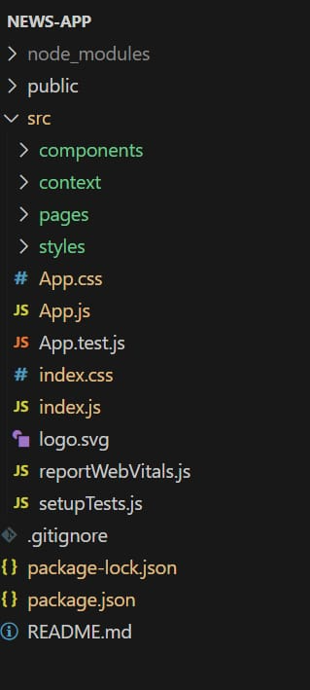

**Running the Application**

Provide commands to start the frontend server locally.

Frontend: npm start in the client directory.

**Component Documentation**

In this project, we’ve split the files into 4 major folders, Components, Context, Pages and Styles. In the pages folder, we store the files that acts as pages at different URLs in the application. The components folder stores all the files, that returns the small components in the application. The context Api will be coded in the context folder. All the styling css files will be stored in the styles folder.

**Styling**

CSS Frameworks/Libraries: Describe any CSS frameworks, libraries, or pre-processors (e.g., Sass, Styled-Components) used.

Theming: Explain if theming or custom design systems are implemented.

**Screenshots and Demo**

Before starting to work on this project, let’s see the demo.

Demo link: https://drive.google.com/file/d/11uBQ3q6BK13SlFLz1ydlbM48QeqWecFL/view?usp=share

**Pre-Requisite:**

*Download Node.js LTS version from <https://nodejs.org/en/download/>

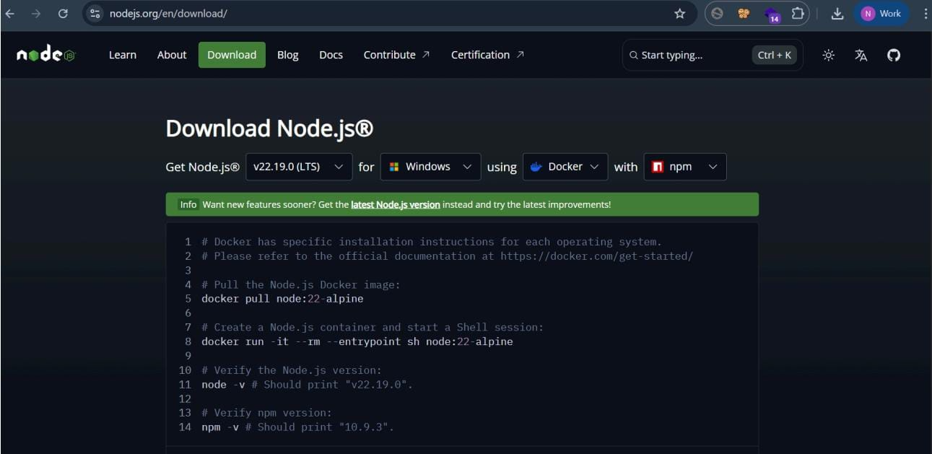

● After downloading, install Node.js by opening the downloaded file and

follow the instructions below.

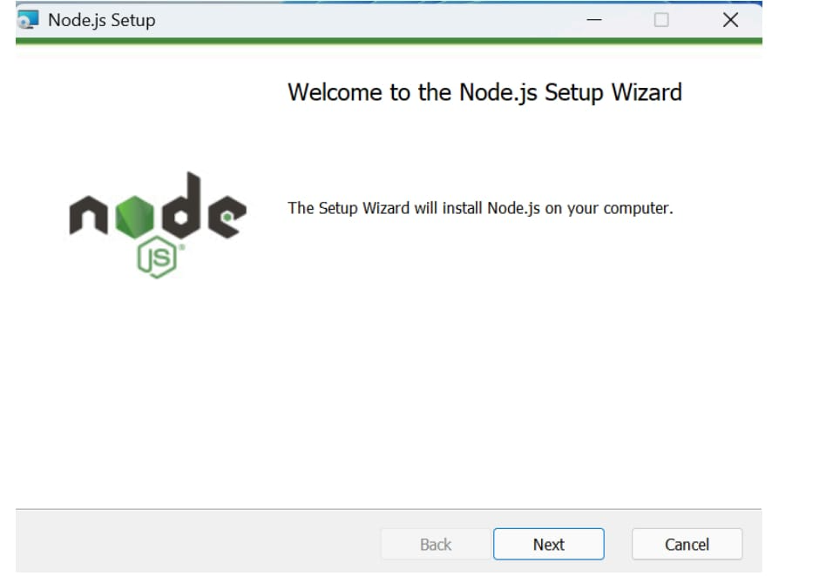

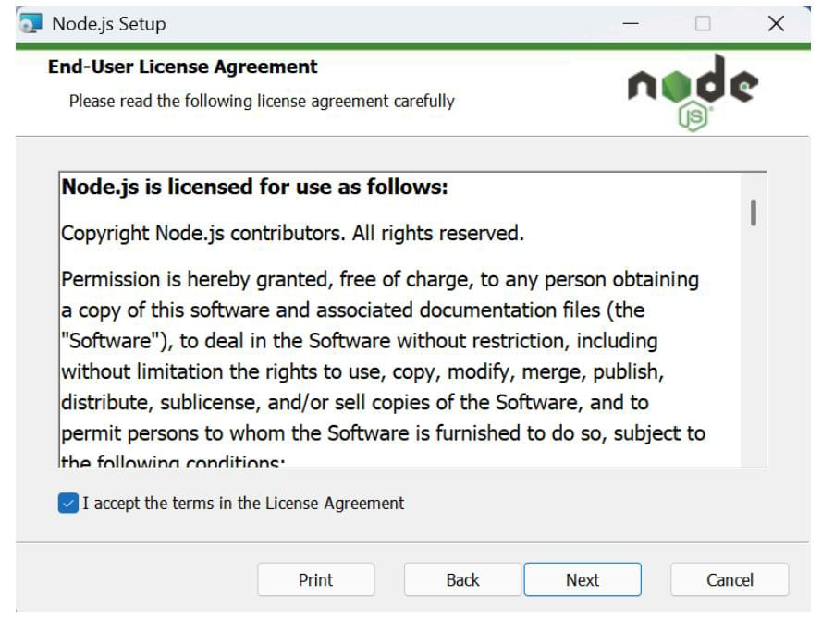

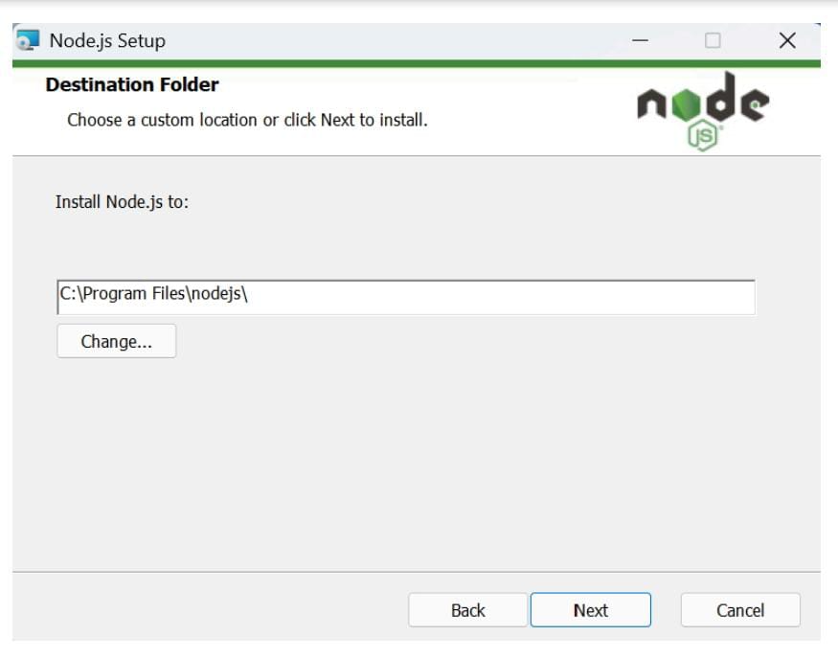

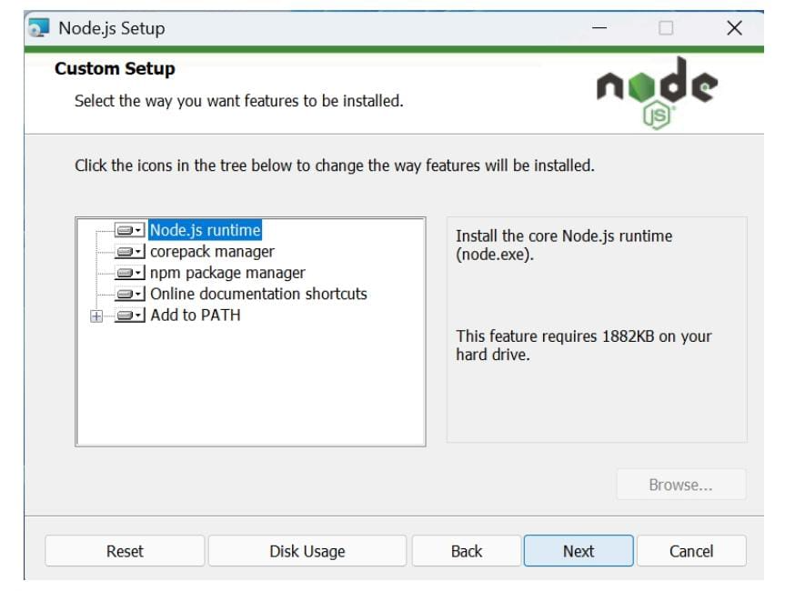

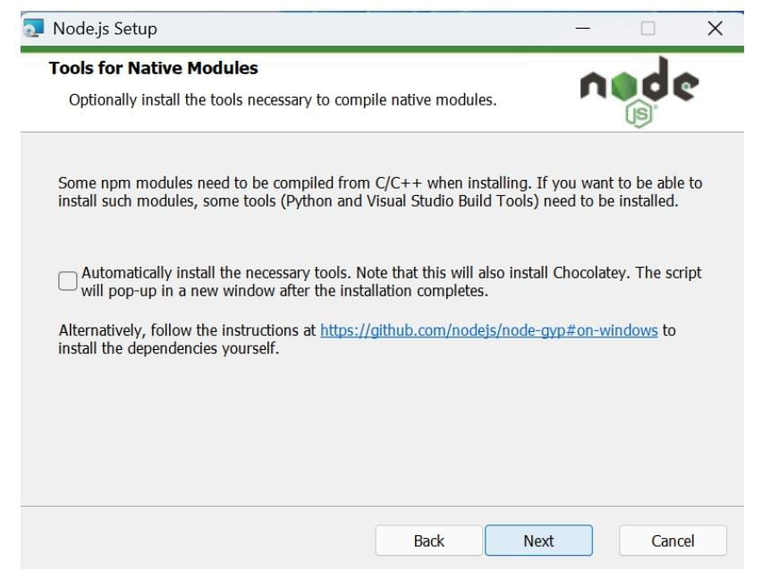

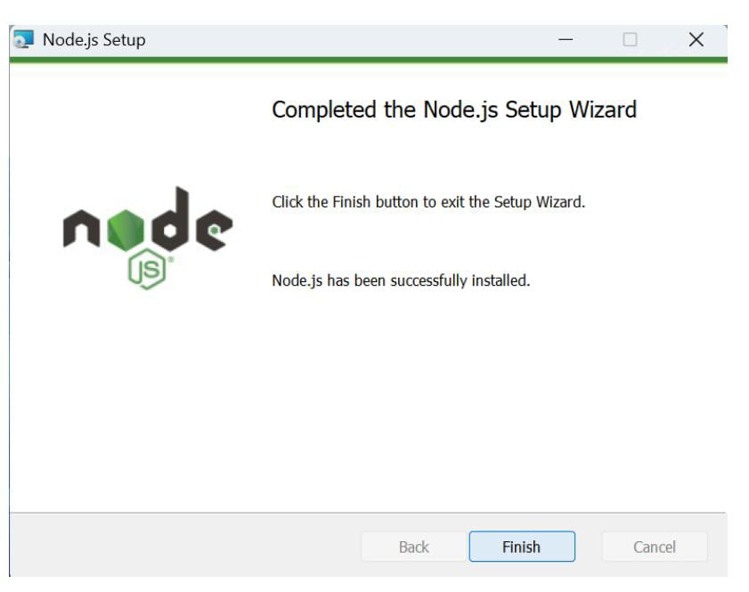

● After installing Node.js, open Windows PowerShell As

Administrator

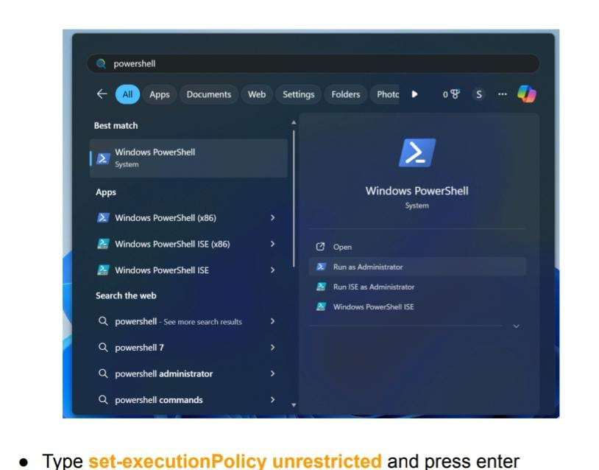

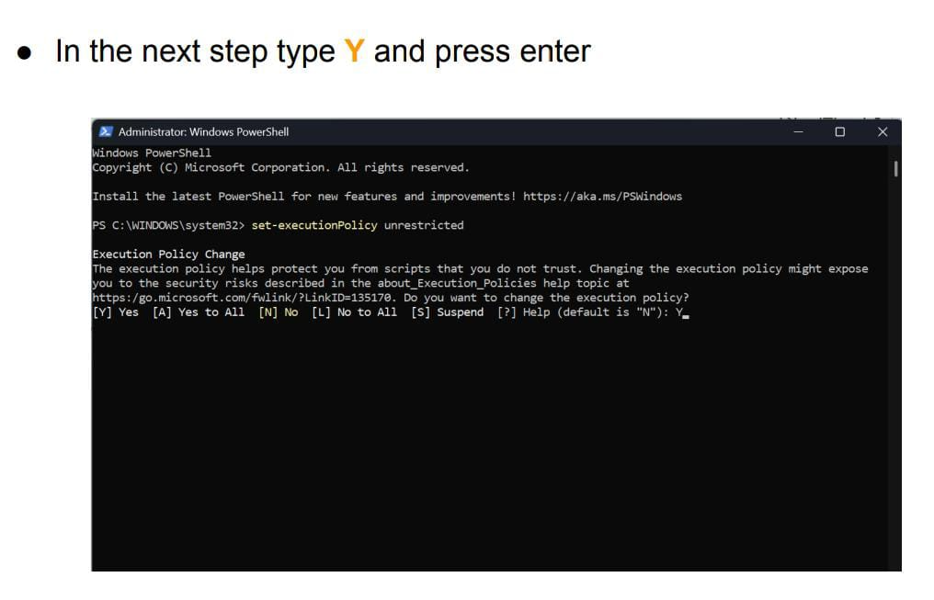

Steps To Download And Execute Project:

● From your SmartInternz portal GoTo Projects → Access Resources

→ Guided Projects → Go To Workspace

●

● Inside Guided Project you can find Project Flow

● Now you can see two links one is the demo video and the other is

the code drive link.

● Click on the code drive link or copy paste that link in your new

chrome tab.

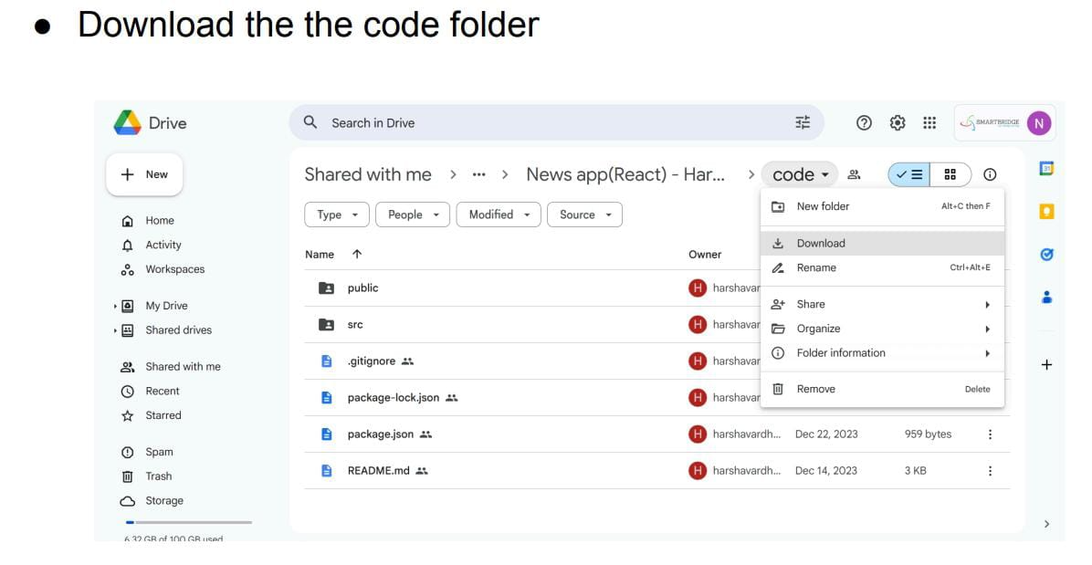

● Now go to downloads and right click on the downloaded zip folder

and click on extract all

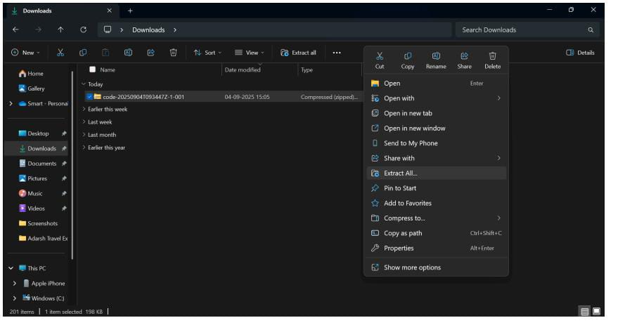

● Now open VS code and open the code folder from the extracted folder.

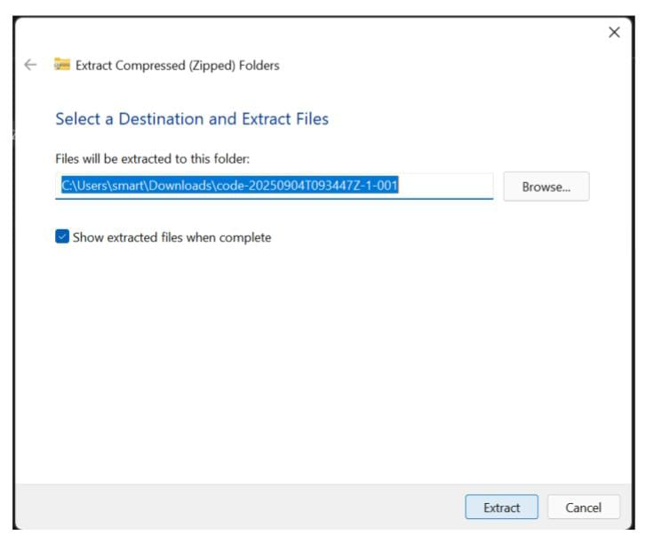

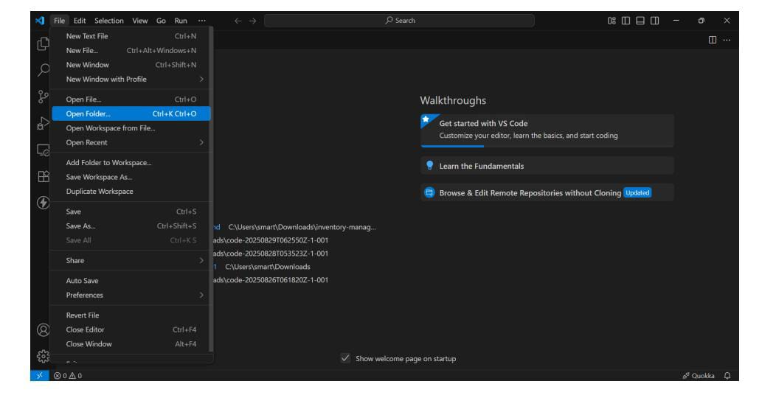

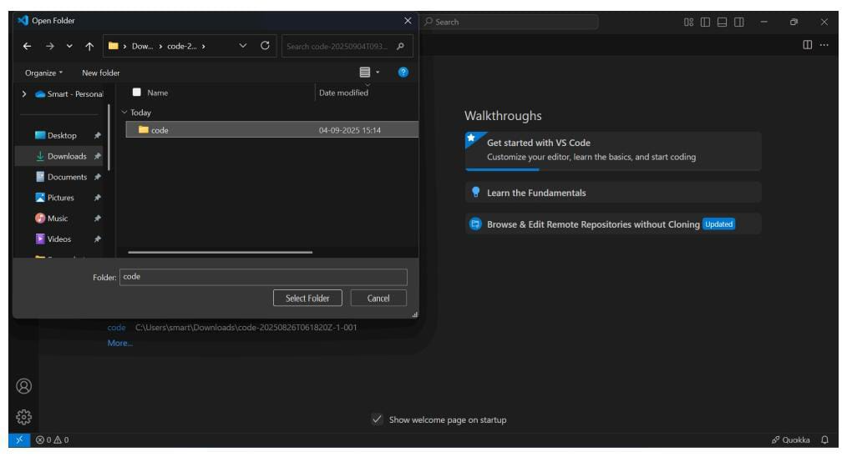

● Now open a new terminal.

● Type npm install in your terminal and press Enter and wait till all the

dependencies gets download

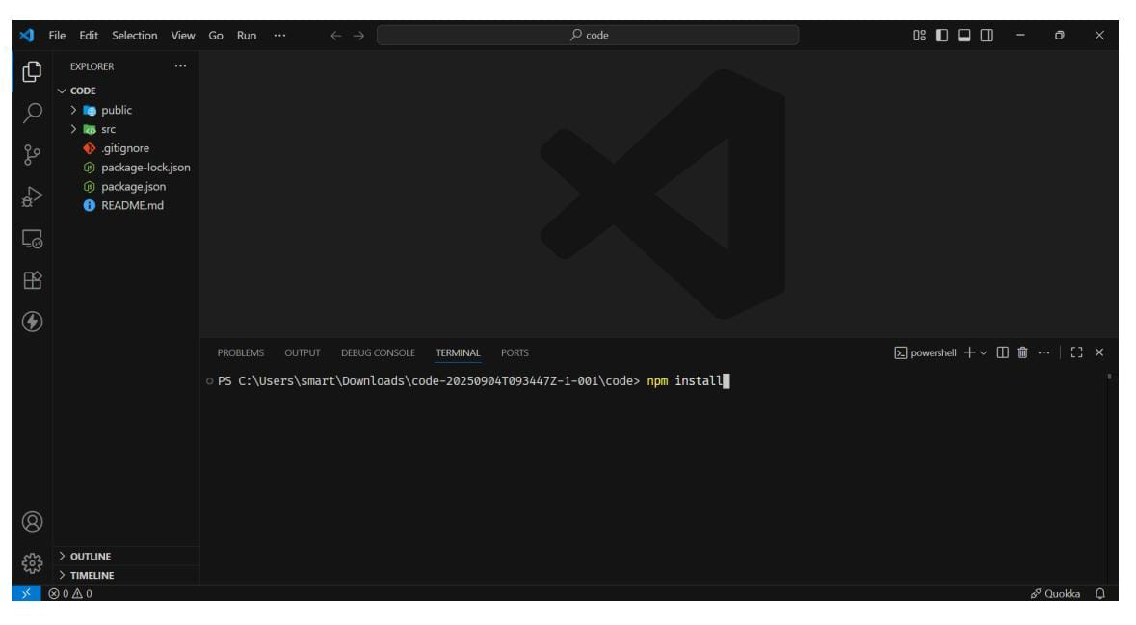

● After all the downloads finishes, now type npm start and press Enter

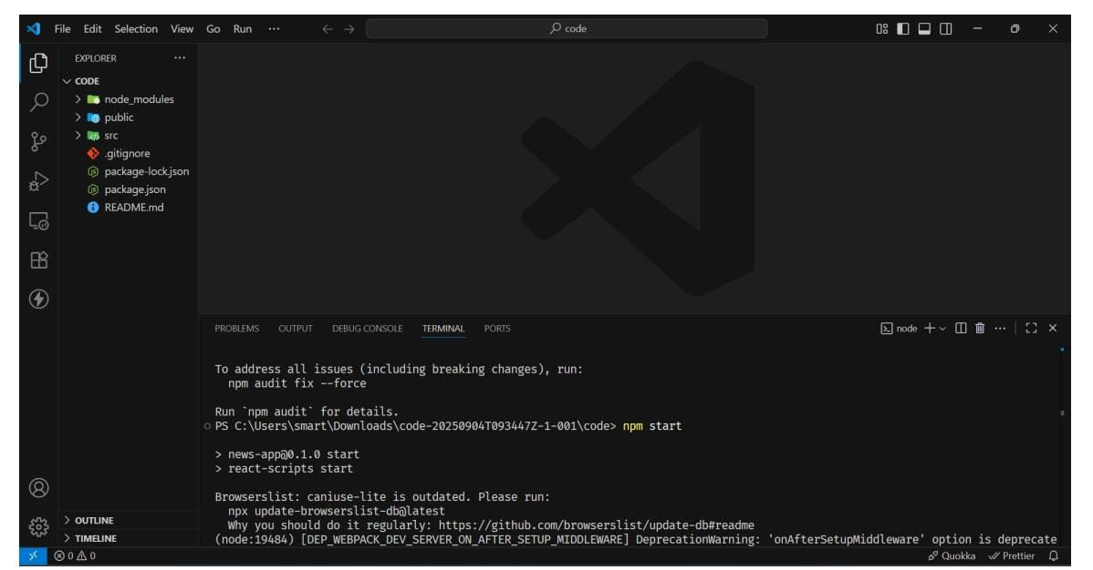

● Now your application will be opened in your browser with url

http://localhost:3000